Accessible Mathematics
10 Instructional Shifts
That Raise Student Achievement
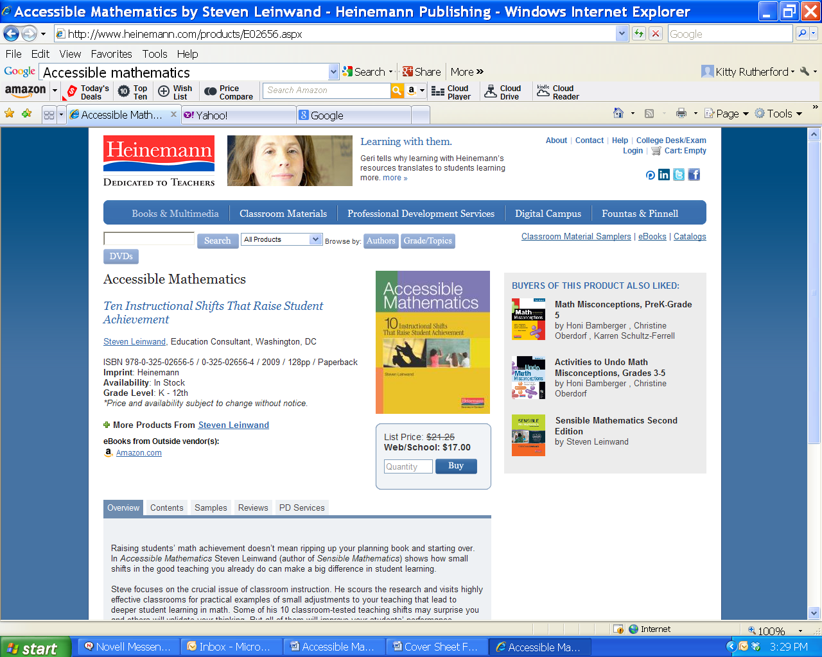

Steven Leinwand



Why should I start or join a book study group?

Book study groups promote conversations among teachers and school staff that will lead to the application of new ideas in classrooms and improvement of existing skills. It is a great way to focus on issues related to school change and also helps to build community in schools.

How do I start a book study group?

To start, seek members from grade-level team members, subject-area groups, and departments. Participation should always be voluntary and membership inclusive. It is also a good idea to seek out the support of your principal, who may be able to help your group with determining a time and location, earning PLUs, or support for refreshments or book purchases.

Decide a meeting schedule, meeting place, the length of the book to read, and what will happen after the book is read. (Will the group disband after the book is read, continue to meet to discuss applications, or read other books?)
It is recommended that meetings last no more than one hour and are held at a consistent time and place. Meeting twice a month keeps ideas of the books present in the minds of teachers without becoming an overwhelming commitment. Finally, it is very important to have a responsible facilitator to remind group members of meetings, keep the group on task, and help run meetings.

What happens during a book study group meeting?

Conversations are at the heart of the book study group. Members share insights, ask questions of the text and each other, and learn from the perspectives of other members. Be sure to discuss the ideas that can be applied directly in the classroom, the potential obstacles to implementation, and what can be done to overcome these obstacles. Journaling can also be used as a powerful learning tool along with a book study. Again, it is very important to have a facilitator to focus discussion and manage meetings.

What happens after the book is finished?

The group should evaluate the book, and members should ask themselves, "So what do we do with the information we have learned from this book?" Think about what types of follow-ups are needed to implement changes in practice and to support study group members. Also plan to examine the impact of these changes. Some groups choose to continue meeting after having read the book to discuss how it has changed their instructional practices. Other groups may choose to continue to meet and read more books on the topic.
If the group decides the book is of value, it may recommend the book to other study groups or make copies available to other faculty through the school library.

What is the role of the principal in book study groups?

The principal plays a key role in championing book study groups. S/he can help support book study groups by finding time during the day for groups to meet or even use faculty meeting time for groups. Principals can also promote study groups by asking members to present their book at a faculty meeting and encourage them to share their insights.
Other creative ways to promote book groups are to work with parent groups to provide faculty with bookstore gift certificates as presents, review books in faculty newsletters, provide refreshment for study group meetings, or designate a faculty reading area in the school's media center.

http://www.eyeoneducation.com/Book-Study-Group-FAQs



View the youtube clip below by Steve Leinwand.

It’s Instruction Stupid

http://www.youtube.com/watch?v=5gWgA4yaFrY

- Reflect.

- Share your thoughts with others.

- Did you get all of that?

- Good news, Steve wrote a book Accessible Mathematics,

- Read the introduction.

- Now what are you thinking?



Chapter 1:


We’ve Got Most of the Answers

“
A shepherd is guarding his flock of 18 sheep when suddenly 4 wolves come over the mountain. How old is the shepherd?”

Discuss scenario above, how do you think students would respond? (page 2)

As you read page 2, think about what compelling evidence arises about the student responses.

On pg. 3 the author describes a typical US classroom and compares it to the typical Japanese classroom.
- Discuss the student behaviors each model of instruction will probably encourage.
- Connect to the Standards for Practice.

After completing the chapter, revisit the list of shifts and discuss the ones you may already be doing.
- What is the outcome?
- Which shifts look as if they might be interesting to explore further?



Chapter 2:

Ready, Set, Review

Instructional Shift 1
Incorporate ongoing cumulative review into every day’s lesson.

Read pages 6-8. Discuss incorporating ongoing cumulative review into everyday’s lesson.

Talk with your team about the types of questions that might be important for your grade level.
- Would these be for review, to practice yesterday’s lesson, to find out about prior knowledge?

Read pages 8-14 by dividing the six sceneries in this chapter among your group.
Read the detailed explanation of each type of question and the purpose it serves.
- How the mathematics addressed relates to each grade-band?
- What types of questions are important at your grade level?
- Would they be review, practice, or to find prior knowledge?

Why is it important for teachers to write their own reviews rather than using something pre-packages?

Then discuss the “So what should we see…” box.
This may be a time to plan with your grade level about the items you would use.

Remember, we’re not always looking for a 6 part quiz. Perhaps you might collaborate on writing the mini-math lessons, or divide and conquer, write 10 apiece. This takes careful thought about purpose and format.

As a group, create a week of questions or tasks for your grade band. Consider the purpose of each.
SO WHAT SHOULD WE SEE IN AN EFFECTIVE MATHEMATICS CLASSROOM?
- A deliberate and carefully planned reliance on ongoing, cumulative review of key skills and concepts
- Using cumulative review to keep skills and understandings fresh, reinforce previously taught materials, and give students a chance to clarify their understandings
- Classes that waste no time and begin with substantive mathematics at the very start of every class
- The use of brief review and whole-class checking of “mini math” questions as an opportunity to re-teach when necessary

Chapter 3:

It’s Not Hard to Figure Out Why Reading Works Better Than Math

Instructional Shift 2
Adapt what we know works in our reading programs and apply it to mathematics instruction.

Reading pg. 15 – paragraph 2 on pg. 17.
- What happens during reading instruction that should occur in all mathematics classrooms? Why?

Reading paragraph 3 on pg. 17 – 18.
- How would you respond if you heard a colleague say, “There isn’t enough time to build from answers, to seek alternative approaches, and to ensure student understanding.” Why?

SO WHAT SHOULD WE SEE IN AN EFFECTIVE MATHEMATICS CLASSROOM?
- Consistent parallels are apparent between the types of questions that require inferential and evaluative comprehension in reading instruction and the probing for ways in which the answers were found, alternative approaches, and reasonableness in mathematics instruction
- All numerical and one-word answers are consistently greeted with a request for justification
- Only reasonable homework assignments are given, and when homework is reviewed, the focus is on explanations and understanding, not on checking for right answers.

Chapter 4:

Picture It, Draw It

Instructional Shift 3

Use multiple representations of mathematical entities.

Read pg. 19 – 21.
The author states that, for many students, mathematical ideas “must be grounded in pictures and models.” Share with your group the experiences you may have had with representations in mathematics. The author makes the case that is our responsibility to use a variety of visual models with our students.
- Do you agree, and if so, how will this idea inform your instructional practice?

Read pg. 21 – 22.
Introduce the idea of measurement benchmarks, real life connections to abstract measurements. Share some examples of times when you used this idea, or when it might be useful for you in the future.

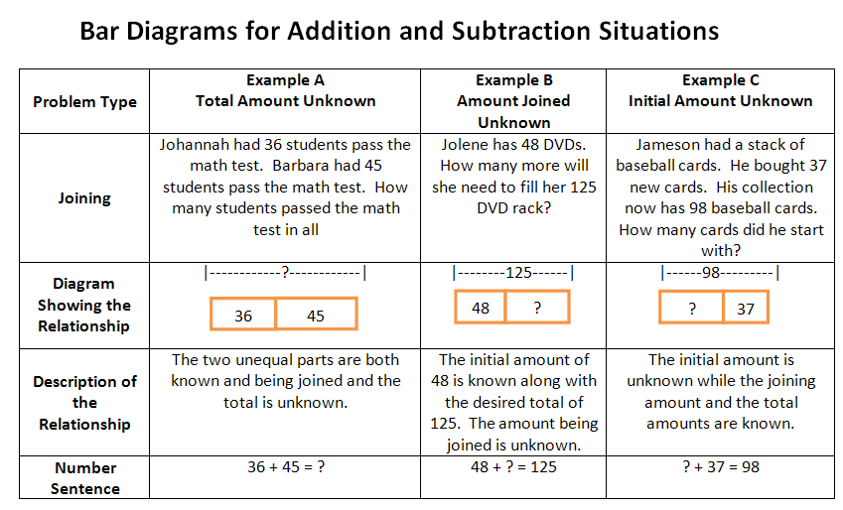
Next, we are introduced to the Singapore Math bar diagram model for visualizing problems. These are really fun and challenging, but also very helpful to many students.
Example:
SO WHAT SHOULD WE SEE IN AN EFFECTIVE MATHEMATICS CLASSROOM?
- Frequent use of pictorial representations to help students visualize the mathematics they are learning
- Frequent use of the numbers line and bar models to represent numbers and word problems
- Frequent opportunities for students to draw or show and then describe what is drawn nor shown

Chapter 5:

Language-Rich Classes

Instructional Shift 4
Create Language-rich classroom routines.

“One of the simplest and easiest ways to take the students who are just below proficient and move them to proficient is to attend to the fact that they just may not have known [particular] mathematical terms.” (p. 32)

Complete “A New Language Task” on page 10-11 of this guide.

What are specific strategies the teacher can use to bolster students’ mathematical language skills?

Have a conversation about the strategies you currently use in your classroom to enrich the mathematics language of your students. Then, select a new strategy from either the book or from a colleague and try it in your class. Follow up at the next meeting by discussing the strategy you used, what you discovered, what you would do the same, and how you may alter the strategy based on your students’ needs.

SO WHAT SHOULD WE SEE IN AN EFFECTIVE MATHEMATICS CLASSROOM?
- An ongoing emphasis on the use and meaning of mathematical terms, including their definitions and their connections to real-world entities and/or pictures
- Students and teachers explanations that make frequent and precise use of mathematics terms, vocabulary, and notation
- An extensive use of word walls that capture the key terms and vocabulary with pictures when appropriate and in English as well as Spanish when appropriate
A New Language!

Count out loud with me to hive… “zurkle, stomp, frump, wheeze, hive”

Zurkle (one)
Stomp (two)
Frump (three)
Wheeze (four)
Hive (five)

Let’s try again… repeat after me… “zurkle, stomp, frump, wheeze, hive”

Everybody up! Let’s try clapping the numbers. Clap zurkle times. Clap frump times. Clap stomp times. (etc.)

Now, let’s try it as we count cubes. (While counting cubes) “zurkle, stomp, frump, wheeze, hive”

In your baggy you should have hive cubes. Check to make sure. Then, switch with a partner and make sure that they have hive cubes.

Now count out wheeze cubes (with own set of cubes).
How do you know that you have wheeze cubes?
What if we took zurkle away? How many would we have? Convince Me.

Everyone show me stomp cubes. Check with your neighbor. Do they have stomp cubes?
What if we had zurkle more? How many would we have? Convince Me.

Find a partner. With a partner, call out a number for your partner to show you with cubes. Be sure that your partner convinces you that you have the amount requested.

Let’s add these new words to our Math Word Wall. Show the Zurkle card. What could we draw or add to this card to help us remember this number, zurkle? Pass out to participant to draw/add. Continue with Stomp, Frump, Wheeze, and hive.

I have written stomp number words on the board. [frump (three) and wheeze (four)]. Turn to a neighbor and tell them hive things they know about these stomp numbers. [Then, generate a list from the participants’ responses.]

Conclude the lesson by asking participants to reflect on the New Language lesson and identify strategies used to help them learn a new language (see below).
Zurkle Reflection

Now that you have experienced a new counting system, what strategies identified in Accessible Mathematics were used to help you learn and apply the new counting language?

Language-Rich Strategy | 
Use follow up statements/questions such as “Convince me.”, “How do you know that…?” (p. 27)
Show the students particular numbers, shapes, equations, etc. and ask students something like: “Tell the person next to you five things you see on the board.” (p. 27). Then generate a list of the vocabulary used in their descriptions. (p. 31)
Use follow up questions to reinforce the critical vocabulary (p. 30)
Provide numerous opportunities for students to discuss, justify, explain in both writing and orally (p. 31)
Provide connections- even the use of mnemonics or language-based memory device (p. 32)
Provide opportunities for students to encounter mathematics orally and in writing (p. 32)
Use mathematical terms repeatedly in context (p. 32)
Link math term to more familiar words until the math terms become internalized (p. 32)
Create an evolving word wall with the students that includes the math term and a visual representation (p. 33)
Model precise use of vocabulary and expect precise vocabulary from students (p. 33)

Chapter 6:

Building Number Sense

Instructional Shift 5

Take every available opportunity to support the development of number sense.

Skim this chapter. Be prepared to discuss the following questions:

- What is number sense? (pg 35)

- Why focus on number sense? (pg 36)

- How can we develop this sense of place value?


SO WHAT SHOULD WE SEE IN AN EFFECTIVE MATHEMATICS CLASSROOM?
- An unrelenting focus on estimation and justifying estimates to computations and to the solution of problems
- An unrelenting focus on a mature sense of place value
- Frequent discussion and modeling about how to use number sense to “outsmart” the problem
- Frequent opportunities to put the calculator aside and estimate or compute mentally when appropriate

Chapter 7:

Milking the Data

Instructional Shift 6
Build from graphs, charts, and tables.

“So?” Lesson Launch
Lead an example of “So?” with data to launch the chapter.

Read pg. 39 – paragraph 1 on pg. 41.
- Why is the “So?” strategy so powerful? Describe what that looks like in a classroom.

Read from paragraph 2 on pg. 41 stopping at example 4.
- How does using data to launch a lesson support quality instruction?


SO WHAT SHOULD WE SEE IN AN EFFECTIVE MATHEMATICS CLASSROOM?
- An abundance of problems drawn from the data presented in tables, charts, and graphs
- Opportunities for students to make conjectures and draw conclusions from data presented in tables, charts, and graphs
- Frequent conversions, with and without technology, of data in tables and charts into various types of graphs, with discussions of their advantages, disadvantages, and appropriateness

Chapter 8:

How Big, How Far, How Much?

Instructional Shift 8
Tie the math to such questions as How Big? How much? How far? To increase the natural use of measurement throughout the curriculum.

Read pages 46-47. Discuss in groups why “no strand in the curriculum is as consistently weak as measurement.

The “Infamous” Skin Problem
You are in the waiting room with your son, when all of a sudden the sirens start blaring and two nurses run to the ER admissions door. You hear one of the nurses exclaim, ”Oh, dear, this is serious. This next patient is completely burned.” The second nurse calmly advises: “Don’t worry. He’s an adult so let’s just order up 1000 square inches of skin from the skin graft bank.”
What would you say?

“Oh good, that’ll be enough to cover it!” or “Oh dear, the patient is in a lot of trouble!”
- Which response is more appropriate?
- Explain your reasoning.
- If you were the patient, estimate the amount of skin you hope was ordered up?
- Explain how you arrived at your estimate.

Read student responds (pages 49-50).
- How does this chapter seem to challenge current practice in teaching measurement as indicated below?

Find the lateral surface area of the cylinder below.
4in
 | 20in

- Would students be able to develop an understanding of how to find the surface area of a cylinder by doing the first problem?
- Which approach is more likely to engage students and develop understanding?
- What mathematical concepts are students learning in each situation?

Read p 50 from “Just look… through p. 53.

Student and adults struggle with the sense of quantity, to assist with the understanding of quantity one may want to read the book How Much is a Million? by David Schwartz
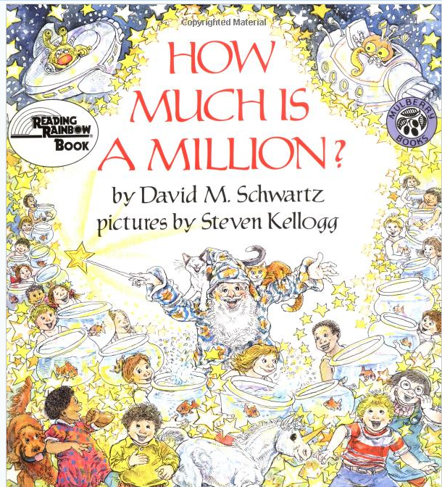

Another great piece of literature for students is How Much, How Many, How Far, How Heavy, How Long, How Tall Is 1000? By Kolan and Walcer

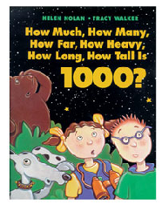
SO WHAT SHOULD WE SEE IN AN EFFECTIVE MATHEMATICS CLASSROOM?
- Lots of questions are included that ask: How big? How far? How much? How many?
- Measurement is ongoing part of daily instruction and the entry point for a much larger chunk of curriculum.
- Students are frequently asked, to find and estimate measures, to use measuring, and to describe the relative size of measure that arise during instruction.
- The teacher offers frequent reminders that much measurement is referential-that is, we use a referent (such as your height or a sheet of paper) to estimate measures.

Chapter 9:

Just Don’t Do It!

Instructional Shift 8
Minimize what is no longer important, and teach what is important when it is appropriate to do so.

Turn and Talk
How essential are these skills?
- Multi-digit multiplication and division
- Fractional parts; such as sevenths and ninths
- Complex formulas
- Simplifying radicals
- Factoring

Reading pg. 54 – paragraph 1 on pg. 57.
- What conclusions can be made as to why few students are successful in mathematics?
- What must be done to improve these situations?

Reading paragraph 2 on pg. 57 – 59.
- Why components are essential for student mastery?

SO WHAT SHOULD WE SEE IN AN EFFECTIVE MATHEMATICS CLASSROOM?
- A curriculum of skills, concepts, and applications that are reasonable to expect all students to master, and not those skills, concepts, and applications that have gradually been moved to an earlier grade on the basis of inappropriately raising standards
- Implementation of a district and state curriculum that includes essential skills and understanding for a world of calculators and computers, and not what many recognize as too much content to cover at each grade level
- A deliberate questioning of the appropriateness of the mathematical content, regardless of what may or may not be on the high-stakes state test, in every grade and course
Chapter 10:

Putting It All in Context

Instructional Shift 9

Embed the mathematics in realistic problems and real-world contexts.

Complete the fact feet on pg. 19 or 20 of this guide book.

Take turns calling out one answer at a time to check your papers.
- Have you seen this scenario before?
- This is essentially a useless review of meaningless problems that very few human being are likely to care about.

Now how about….

“Peter Dowdeswell of London, England, holds the world record for pancake consumption.”


- Is there anything you would like to know?
- Elicit questions… Participants formulate their own questions and solutions – motivated by the context.
- How many pancakes? etc…. different grade bands would ask different questions according to their level of mathematics.

Read 60-62. So what do you think?

Skim remaining chapter to find……
- Steve’s “secret” to raising mathematics achievement? (pg.67)
SO WHAT SHOULD WE SEE IN AN EFFECTIVE MATHEMATICS CLASSROOM?
- Frequent embedding of the mathematical skills and concepts in real-world situations and context
- Frequent use of “So, what questions arise from these data or this situation?”
- Problems that emerge from teachers asking, “When and where do normal human beings encounter the mathematics I need to teach?”

Other possible resources:

Guinness Book of World Records   | Math Curse  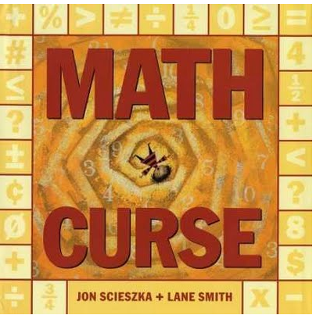

On-line resources: http://www.guinnessworldrecords.com/



Fact Sheet

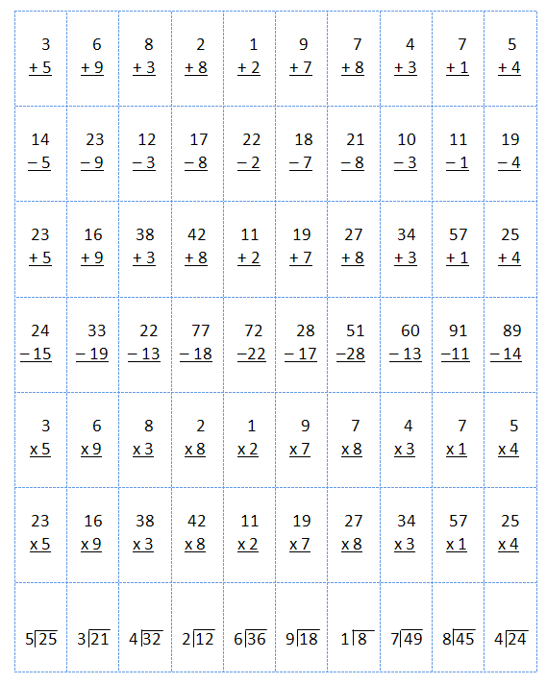

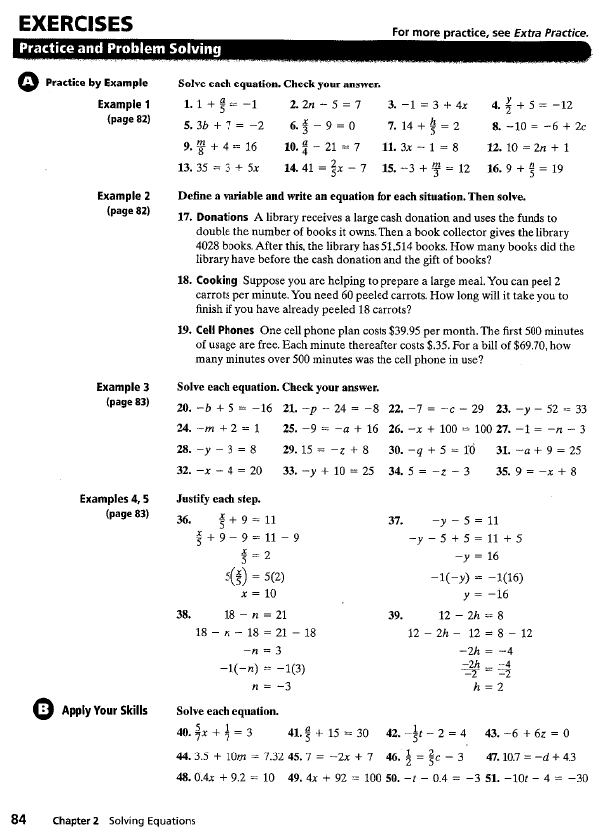

Chapter 11:

Just Ask Them “Why?”

Instructional Shift 10
Make “Why?” “How do you know?” and “Can you explain?” classroom mantras.

Failing to follow up a student’s answer with “Why?” or ‘How did you get that answer?” or “Can you explain your thinking?” is a serious missed opportunity. It’s a though we’re programmed to receive the “right answer.” Or think about any of the hundreds of two- or three-word or one number answers that pass for discourse in the typical mathematics class.

Read chapter to answer the following questions.
- What does active discourse reinforce? (pg 70)

- Why follow up most answers with a request for an explanation? (pg. 71)



SO WHAT SHOULD WE SEE IN AN EFFECTIVE MATHEMATICS CLASSROOM?
- Every student answer is responded to with a request for justification.
- Both teachers and students consistently and frequently use “Why?” “Can you explain that?” “How do you know?” or equivalent questions.
- Dismissive responses such a “No,” “Wrong,” “Not quite,” and their equivalents are absent from the classroom.

Chapter 12:


Punting Is Simply No Longer Acceptable

Reading pg. 72 – pg. 73.
- What are the characteristics of an effective lesson plan and why is it necessary to plan carefully?

Reading pg. 74 – pg. 75
- Why is it important to work homework problems and example problems ahead of time?


“Lesson Plan” Activity
Using the lesson plan template provided, plan and develop a lesson appropriate to your grade band. There’s an example on pg. 77 of “Accessible Mathematics”.

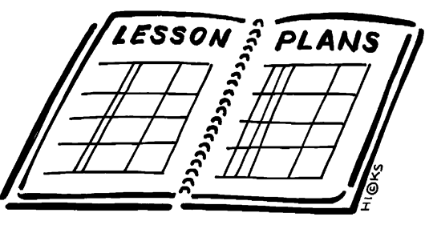

Chapter 13:

We All Have a Role to Play

and Teachers Can’t Do It Alone

The instructional shifts being advocated in the book require understanding, attention, and commitment on part of many beyond the classroom.

Read chapter, think about, and discuss the questions below?

- Who might be the players involved in advocating these instructional shifts?

- What expectations would we have for each of the players in advocating these instructional shifts? (pages 79-82)

We’re in this together, we are an interdependent system. The implementation of these shifts requires collaboration and professional interaction with all players.

- What are some suggestions of things that need to happen to help with the implementation of the shifts included in this book? (pages 83-85)

Now……..
Which shifts do you feel are most important and want to start on now?
What is your role?
What plans you do have in place to support these shift?



